Blog Details of S. K. Sridhar, Dept. of Chemistry
S.No. | Sub.Code | Title of the Paper | Class | Blog Link | QR Code
1 | 192361 | Allied Chemistry Paper I | I B.Sc., Mathematics | https://skschemistry.blogspot.com/2020/12/Allied-1.html | 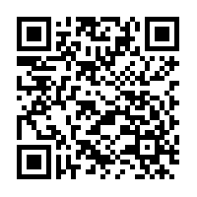
2 | 192321 | Elective Paper I - Applied Chemistry | II B.Sc., Chemistry | https://skschemistry.blogspot.com/2020/12/Applied-Chemistry.html | 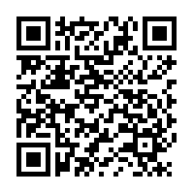
3 | 196310 | Physical Chemistry II | II M.Sc., Chemistry | https://skschemistry.blogspot.com/2020/12/Physical-Chemistry-II.html | 